# Flowchart

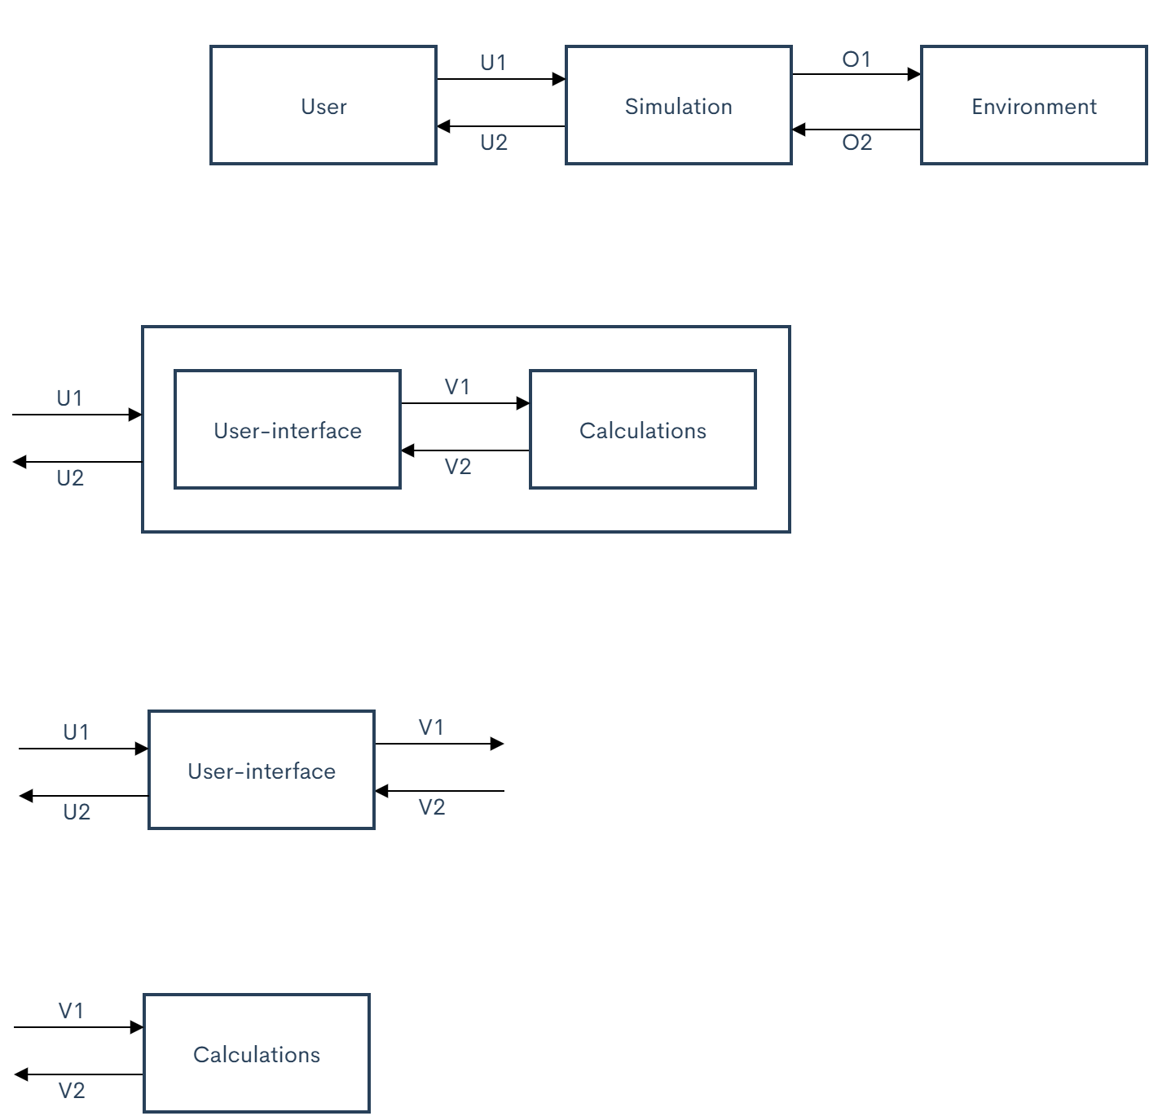

Figure User-interface subsystem flowchart

## Unique identifiers

|  |  |
| --- | --- |
| Unique ID | Long Name |
| U1 | User input |
| U2 | Simulation output |
| V1 | User-interface sub-system output |
| V2 | Calculation sub-system output |

# Table of limits

|  |  |  |  |  |  |
| --- | --- | --- | --- | --- | --- |
| Interaction | Symbol | Min. | | Max. | Unit |
| -> U1 | | | | | |
| *Data from normal users* | | | | | |
| Limit input | | | | | |
| Boat speed | $$V_{input}$$ | | 0 | 8.33 | m/s |
| *Data from administrators* | | | | | |
| Properties input (used to set up calculation) | | | | | |
| Current-Torque relation coefficient | - | - | | - | - |
| Friction coefficient | $$µ_{bear}$$ | - | | - | V/A |
| Seal coefficient | - | - | | - | A/T |
| Load | - | 0 | | - | U/- |
| r_shaft | - | 0 | | - | N |
| Gear friction coefficient |  |  | |  | m |
| Gear transmission ratio |  | 0,1 | | 10 | # |
| Gear index circle pressure angle |  | 15 | | 25 |  |
| Gear index circle diameter of driving wheel |  | 0 | | - | m |
| Gear addendum radius |  | 0 | | **-** | m |
| Gear dedendum radius |  | 0 | | - | m |
| Gear tooth number |  | 0 | | **-** | **-** |
| Gear tooth width |  | 0 | | R | m |
| Gear modulus |  | 0 | | - | - |
| Gear immersion depth |  | 0 | | R | m |
| Gear lubricant viscosity |  | 0 | | **-** | **-** |
| Gear lubricant density | $$ρ$$ | 0 | | - | $${kg}/{m^{3}}$$ |
| Propeller diameter | $$d_{prop}$$ | 0,1 | | 0,5 | m |
| Thrust deduction coefficient | $$t_{T}$$ | - | | - | - |
| Wake fraction coefficient | - | - | | - | w |
| Liquid density | $$K_{T}$$ | 0 | | - | kg/m^3 |
| -> U2 | | | | | |
| *Data to normal users and administrators* | | | | | |
| Limit output | | | | | |
| Thrust | $$F_{T}$$ | 0 | | 500 | N |
| Rotational speed propeller | $$ϖ_{P}$$ | 0 | | 2300 | rpm |
| Power input | $$P_{input}$$ | 0 | | 9700 | W |
| Power output | $$P_{output}$$ | 0 | | 8500 | W |
| Power loss | $$P_{loss}$$ | 0 | | 8500 | W |
| Efficiency | $$η$$ | 0 | | 100 | % |
| Warning and propmts | - | - | | | - |

|  |  |  |  |  |
| --- | --- | --- | --- | --- |
| Interaction | Symbol | Min. | Max. | Unit |
| -> V1 | | | | |
| *Data to calculation sub-system* | | | | |
| Limit output | | | | |
| Boat speed | V_input | 0 | 8.33 | m/s |
| Properities output (used to set up calculation) | | | | |
| Current-Torque relation coefficient | - | - | - | - |
| Friction coefficient | $$µ_{bear}$$ | - | - | V/A |
| Seal coefficient | - | - | - | A/T |
| Load | - | 0 | - | U/- |
| r_shaft | - | 0 | - | N |
| Gear friction coefficient |  |  |  | m |
| Gear transmission ratio |  | 0,1 | 10 | # |
| Gear index circle pressure angle |  | 15 | 25 |  |
| Gear index circle diameter of driving wheel |  | 0 | - | m |
| Gear addendum radius |  | 0 | **-** | m |
| Gear dedendum radius |  | 0 | - | m |
| Gear tooth number |  | 0 | **-** | **-** |
| Gear tooth width |  | 0 | R | m |
| Gear modulus |  | 0 | - | - |
| Gear immersion depth |  | 0 | R | m |
| Gear lubricant viscosity |  | 0 | **-** | **-** |
| Gear lubricant density | $$ρ$$ | 0 | - | $${kg}/{m^{3}}$$ |
| Propeller diameter | $$d_{prop}$$ | 0,1 | 0,5 | m |
| Thrust deduction coefficient | $$t_{T}$$ | - | - | - |
| Wake fraction coefficient | - | - | - | w |
| Liquid density | $$K_{T}$$ | 0 | - | kg/m^3 |
| Current-Torque relation coefficient  Friction coefficient | - | - | - | - |
| $$µ_{bear}$$ | - | - | V/A |
| -> V2 | | | | |
| *Data from calculation sub-system* | | | | |
| Limit input | | | | |
| Thrust | $$F_{T}$$ | 0 | 500 | N |
| Rotational speed propeller | $$ϖ_{P}$$ | 0 | 2300 | rpm |
| Power input | $$P_{input}$$ | 0 | 9700 | W |
| Power output | $$P_{output}$$ | 0 | 8500 | W |
| Power loss | $$P_{loss}$$ | 0 | 8500 | W |
| Efficiency |  | 0 | 100 | % |